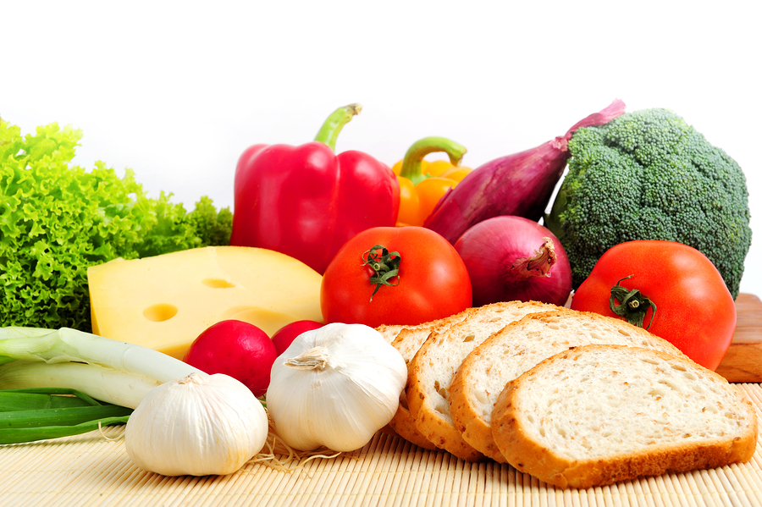
August 2019
SKYBRIDGE

Monday | Tuesday | Wednesday | Thursday  August 1st | Friday  August 2nd
August 5th | August 6th | August 7th | August 8th | August 9th
August 12th | August 13th | August 14th | August 15th | August 16th
August 19th | August 20th | August 21st | August 22nd | August 23rd
 |  | FIRST DAY!  Hand-Breaded Chicken Tenders  Oven Roasted Sweet Potatoes  Cauliflower & Peas  Daily Fruit | Beef & Cheese Tacos  Spanish Rice  Seasoned Green Beans  Fruit of the Day | Turkey Frito Pie  Optional: Grated Cheddar  Golden Corn & Cauliflower  Daily Fruit
August 26th | August 27th | August 28th | August 29th | August 30
Grilled Cheese Sandwich w/Creamy Tomato Soup  Daily Fruit | Baked Ziti w/Beef and Roasted Veggie Marinara Seasoned Green Beans  Daily Fruit | Glazed Teriyaki Chicken  Steamed Basmati Rice  Broccoli & Peppers  Fresh Fruit | Chicken & Waffle  Seasonal Vegetables  Fruit of the Day | Sloppy Joe on Central Market Bun  Oven-Fried Potatoes  Seasonal Green Beans
Fruit selection for the day includes one of the following based on availability:
Organic: Grapes Apples Strawberries Pears Other: Banana Pineapple Mandarin Oranges
Local: Honeydew Oranges Watermelon Cantaloupe Peaches

